Lily Kendall
Assignment 1
Machine Learning 1
Due 1/26/26

Note: this document contains only the answer to the questions. All code and work will be in the python file.

Question 1

- (10 points) Generate a line plot of the monthly CCSA averages versus the reported months. Both axes must be correctly labeled, and the tick marks must be appropriately formatted to receive full credit.

Monthly averages over time:

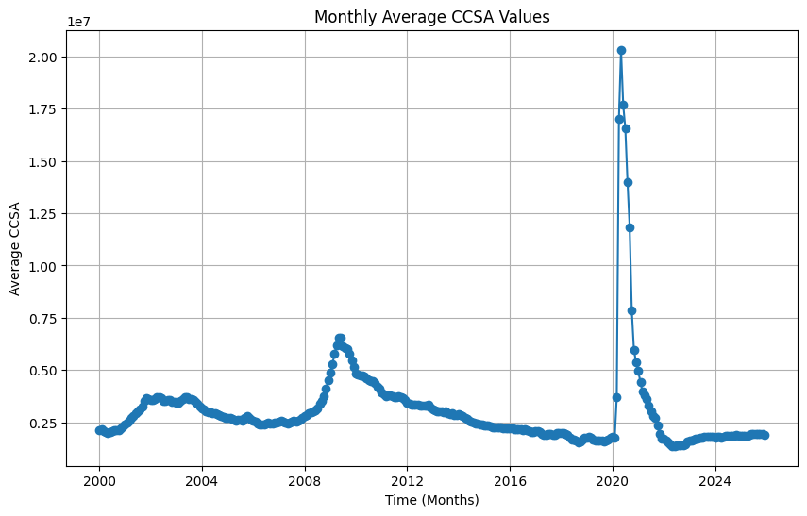

Average by month over the whole dataset (all years):

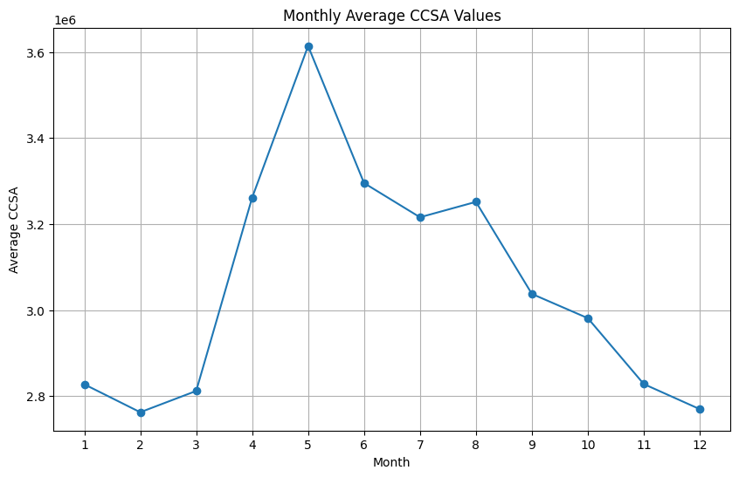

- (10 points) Determine the Pearson correlations among the weekly counts. To this end, calculate the pairwise Pearson correlation between the counts of the rth and sth weeks of each month, where r and s run from 1 to 5 inclusively. Use all available non-missing counts for each pair to calculate the correlations. Present the correlations in a 5 × 5 matrix with proper row and column labels.

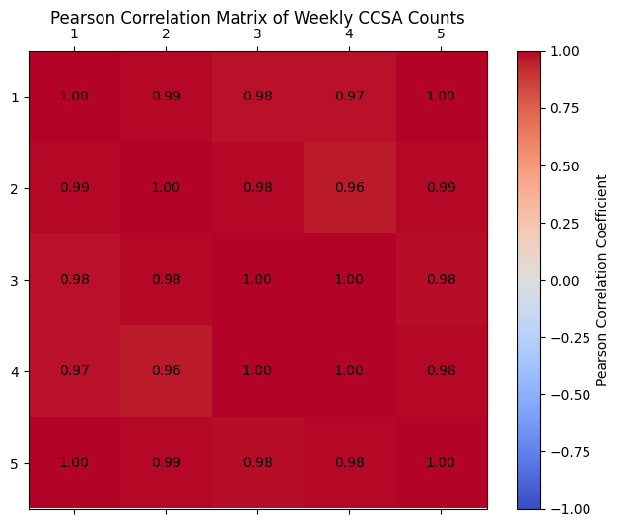

- (10 points) Assign observations from 2000 to 2015, inclusive, to the Training partition. The Testing partition will contain the remaining ten years of observations. Because not all months have a fifth week, further split the Training partition by month into two groups. The first group includes months with fifth-week counts. The second group comprises months with only four weeks of counts. Generate principal components for the two groups in the Training partition. How many principal components do you choose for each group? Also, what percentage of the total variance do the principal components explain in each group? Please show your work to justify your choices.

Explained variance ratios for months with fifth week:
[9.97511968e-01 1.07964099e-03 7.29877266e-04 3.76350887e-04 3.02162617e-04]
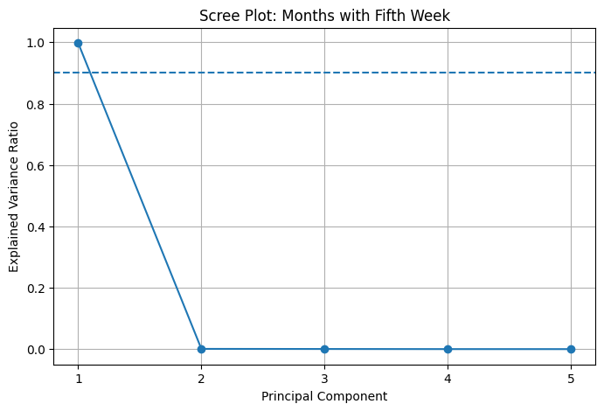

Explained variance ratios for months without fifth week:
[9.98416754e-01 1.07738764e-03 2.65291238e-04 2.40567482e-04]

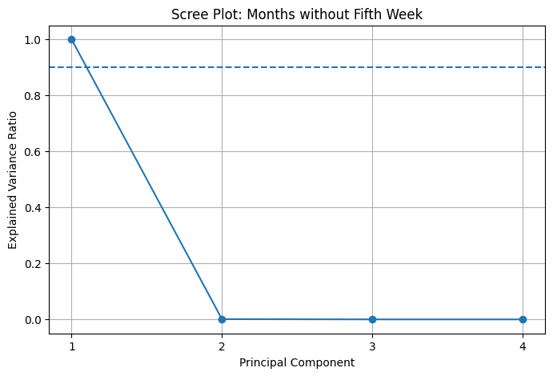

I would choose one principal component for both groups because from the plots and variance ratios, we can see that almost all the variance is explained by the first component (around 99%). In the scree plot, we can see the explained variance drops off significantly after the first component.

- (10 points) Apply the principal components to the Testing partition. Of course, apply the principal components generated from months with only four weeks of counts to the months in the Testing partition that have four weeks. Likewise, apply the principal components generated from months with five weeks of counts to the months in the Testing partition that also have five weeks. Finally, concatenate the principal components’ values in the Testing partition by year and month. What are the variances of the principal components applied to the Testing partition?

Variances of the principal components in the Testing partition:
PC1 4.959071e+13
dtype: float64

- (10 points) What interpretations will you give to the coefficients of the principal components? For example, are any principal components essentially the weighted mean of the weekly counts? How would you rescale the coefficients, if necessary, to ensure they have practical meaning?

The only component we have is the first principal component. The coefficient of the component represents the contribution of that week’s count to the component itself. Because the component explains almost all of the variance and the values are roughly similar, we can interpret them as a weighted monthly average. To rescale the coefficients for interpretation, we should normalize them, making their sum equal to 1. Additionally, the values are negative, so we should multiply by -1 because the sign is arbitrary, making the value easier to interpret.

Question 2

- (10 points) Discover association rules with a minimum Support of five incidents and a minimum Lift of one. We only want association rules whose Consequents contain a particular 1-item set. That 1- item set is either {Arrest is True} or {Arrest is False}. After removing redundant rules, how many association rules remain with {Arrest is True} in the consequent? How many association rules remain with {Arrest is False} in the consequent?

Number of non-redundant rules with Arrest=True in the consequent: 30
Number of non-redundant rules with Arrest=False in the consequent: 47

- (10 points) Plot the Support values against the Confidence values of the association rules of interest in Part (b). Use the checkmark ('$\u2713$') if an arrest is made and the 'x' marker if no arrest is made. Also, color-code the markers according to the lift values in the rules.

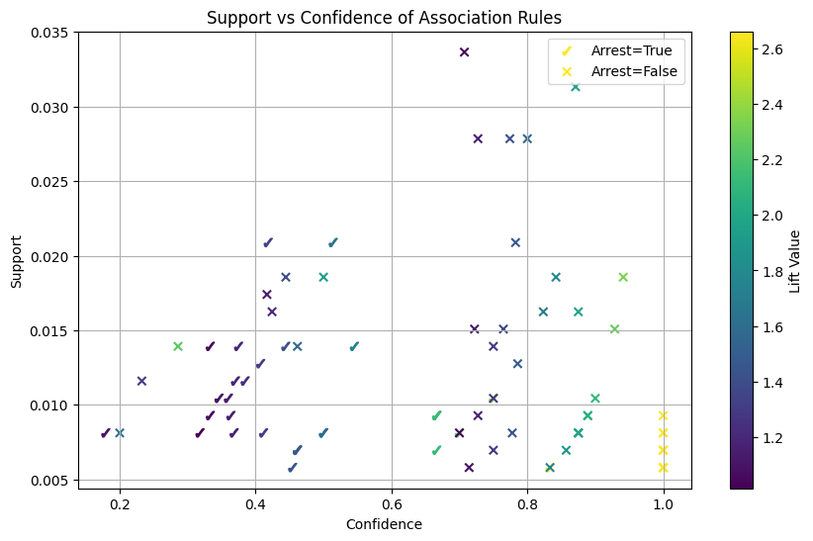

- (10 points) Apply the association rules to the testing partition and produce the Confusion Matrix. What is the accuracy? Also, what percentage of observations do the association rules fail to deliver any definitive predictions for?

Corrected Confusion Matrix:
Predicted Arrest Predicted No Arrest
Actual Arrest 27 82
Actual No Arrest 67 203

Accuracy (excluding 'None'): 60.69%
No Prediction Rate: 7.56%

- (10 points) Based on the test partition results, what are the top three most invoked rules for predicting an arrest? What are the top three most invoked rules for predicting no arrest? For each rule, list the rule number, the number of times it was invoked, the rule criterion, the confidence value, and the lift value.

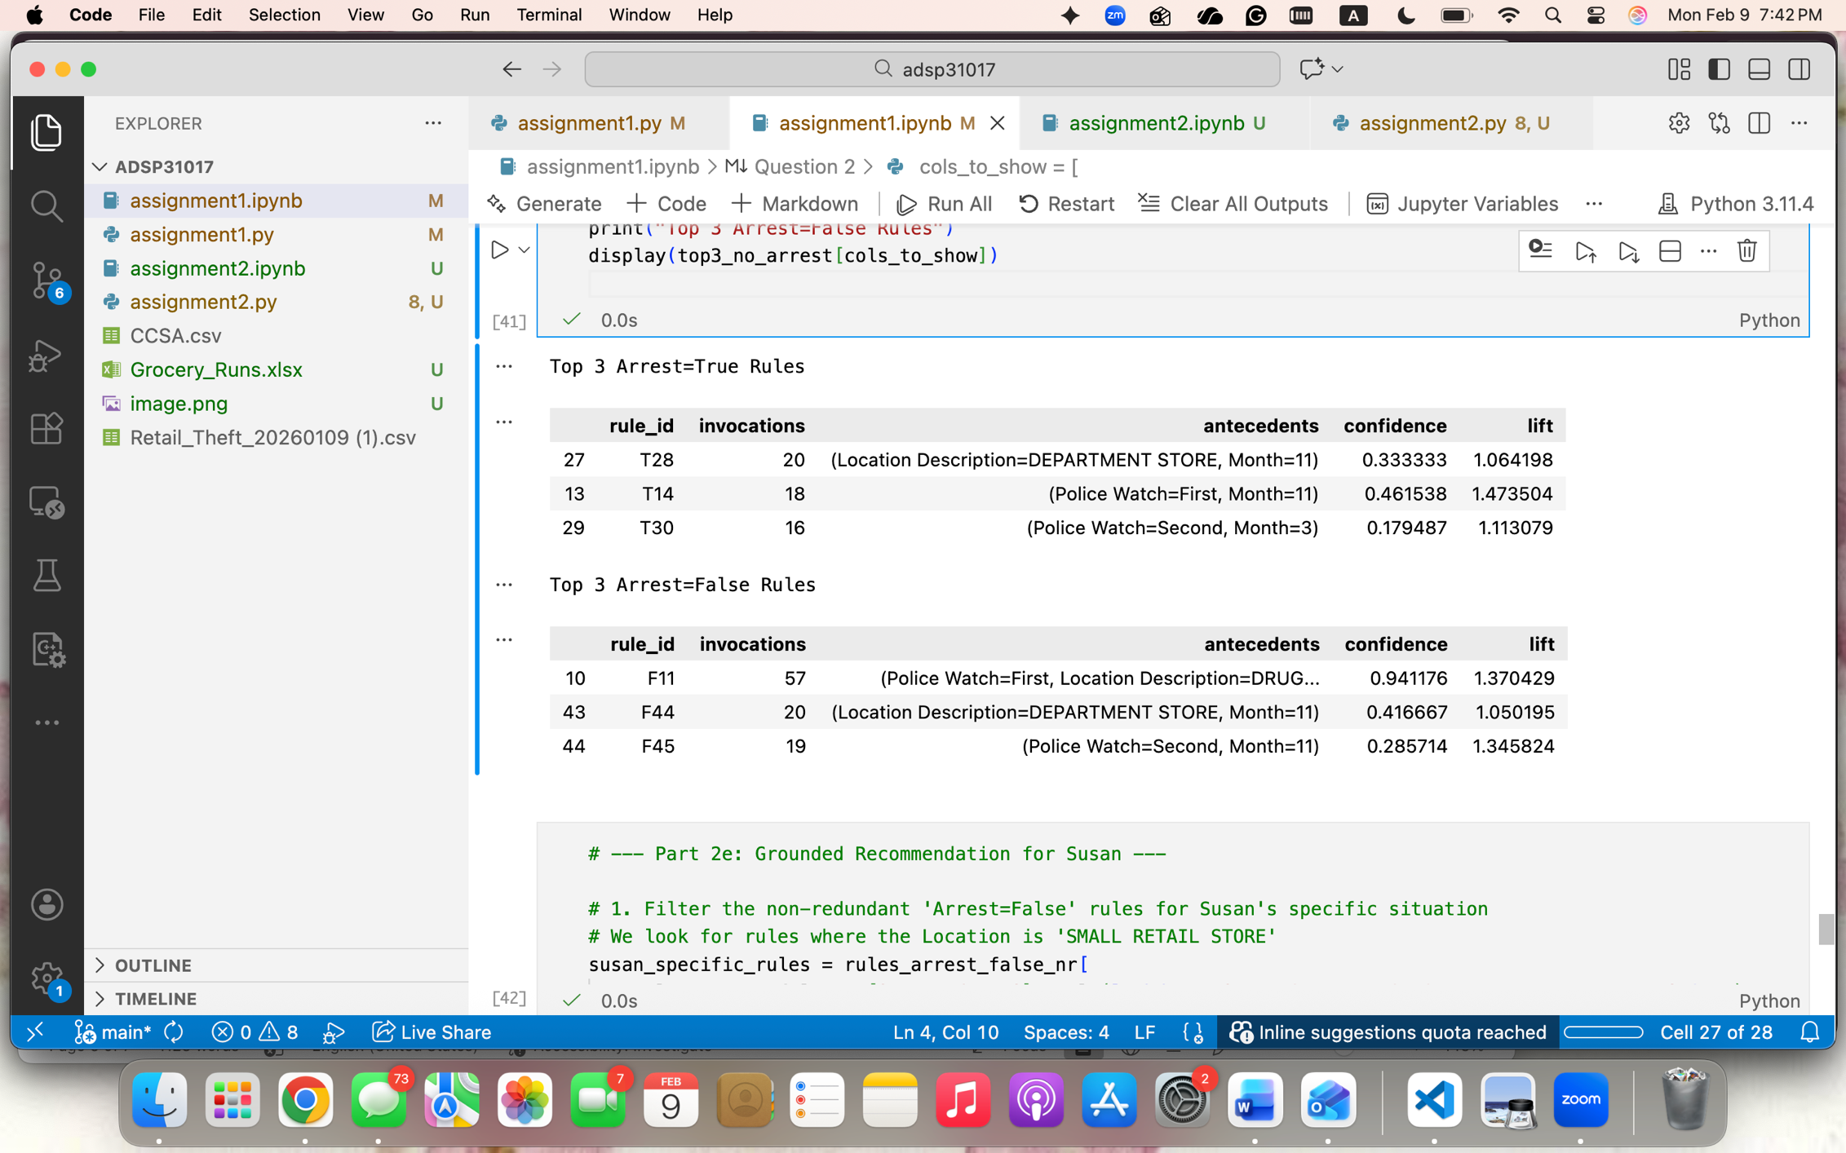

- (10 points) Suppose Susan owns a SMALL RETAIL STORE in downtown Chicago, and she will hire a private security guard to protect her store from retail theft. Based on your rules, when should Susan request the security guard be on duty, particularly when the police are less available?

Rules for SMALL RETAIL STORE leading to No Arrest:
antecedents \
3 (Police Watch=First, Month=1, Location Descrip...
4 (Police Watch=First, Location Description=SMAL...
8 (Police Watch=Second, Location Description=SMA...
11 (Police Watch=Second, Month=4, Location Descri...
20 (Police Watch=First, Location Description=SMAL...
21 (Police Watch=Second, Location Description=SMA...
23 (Police Watch=Second, Month=12, Location Descr...
25 (Police Watch=Second, Location Description=SMA...
40 (Location Description=SMALL RETAIL STORE, Mont...
46 (Month=6, Location Description=SMALL RETAIL ST...

consequents confidence lift
3 (Arrest=False) 1.000000 1.456081
4 (Arrest=False) 1.000000 1.456081
8 (Arrest=False) 1.000000 1.456081
11 (Arrest=False) 0.928571 1.352075
20 (Arrest=False) 0.857143 1.248069
21 (Arrest=False) 0.842105 1.226174
23 (Arrest=False) 0.823529 1.199126
25 (Arrest=False) 0.785714 1.144064
40 (Police Watch=Second, Arrest=False) 0.461538 1.163293
46 (Police Watch=First, Arrest=False) 0.200000 1.180822

Susan should hire the security guard during the first police watch because the rules for small retail stores that lead to no arrest are most commonly during the first police watch and have the highest confidence (100%). Because the rules lead to no arrest this suggests there is less availability of police during that time.

